CoderDojoDC Raspberry Pi Workstation Setup

Everything you will need is stored on our metal storage cart. We have labeled all items needed for your workstation setup. There are 6 stations, so the plastic containers, monitors, and keyboards are labeled from 1 to 6. Make sure you take a matching set.

**From the storage cart, take one each of these - and make sure they have the same number**

1. Keyboard
2. Monitor
3. Clear box with Raspberry Pi and accessories

In this clear box with purple handle, you will find the following items

1. Raspberry Pi 3 with battery attached
2. green GrovePi box
3. microSD card (probably already inserted into Raspberry Pi)
4. Mouse
5. USB to miniUSB cable (for battery)
6. *power supply (optional - we are now using the battery pack attached to the RaspberryPi)*
7. *Headphones if you’d like them*
8. *MicroSD card reader w/ USB cable*

**Also from the storage cart, in another clear box with purple handles, you will need one each of**

1. HDMI cable for monitor

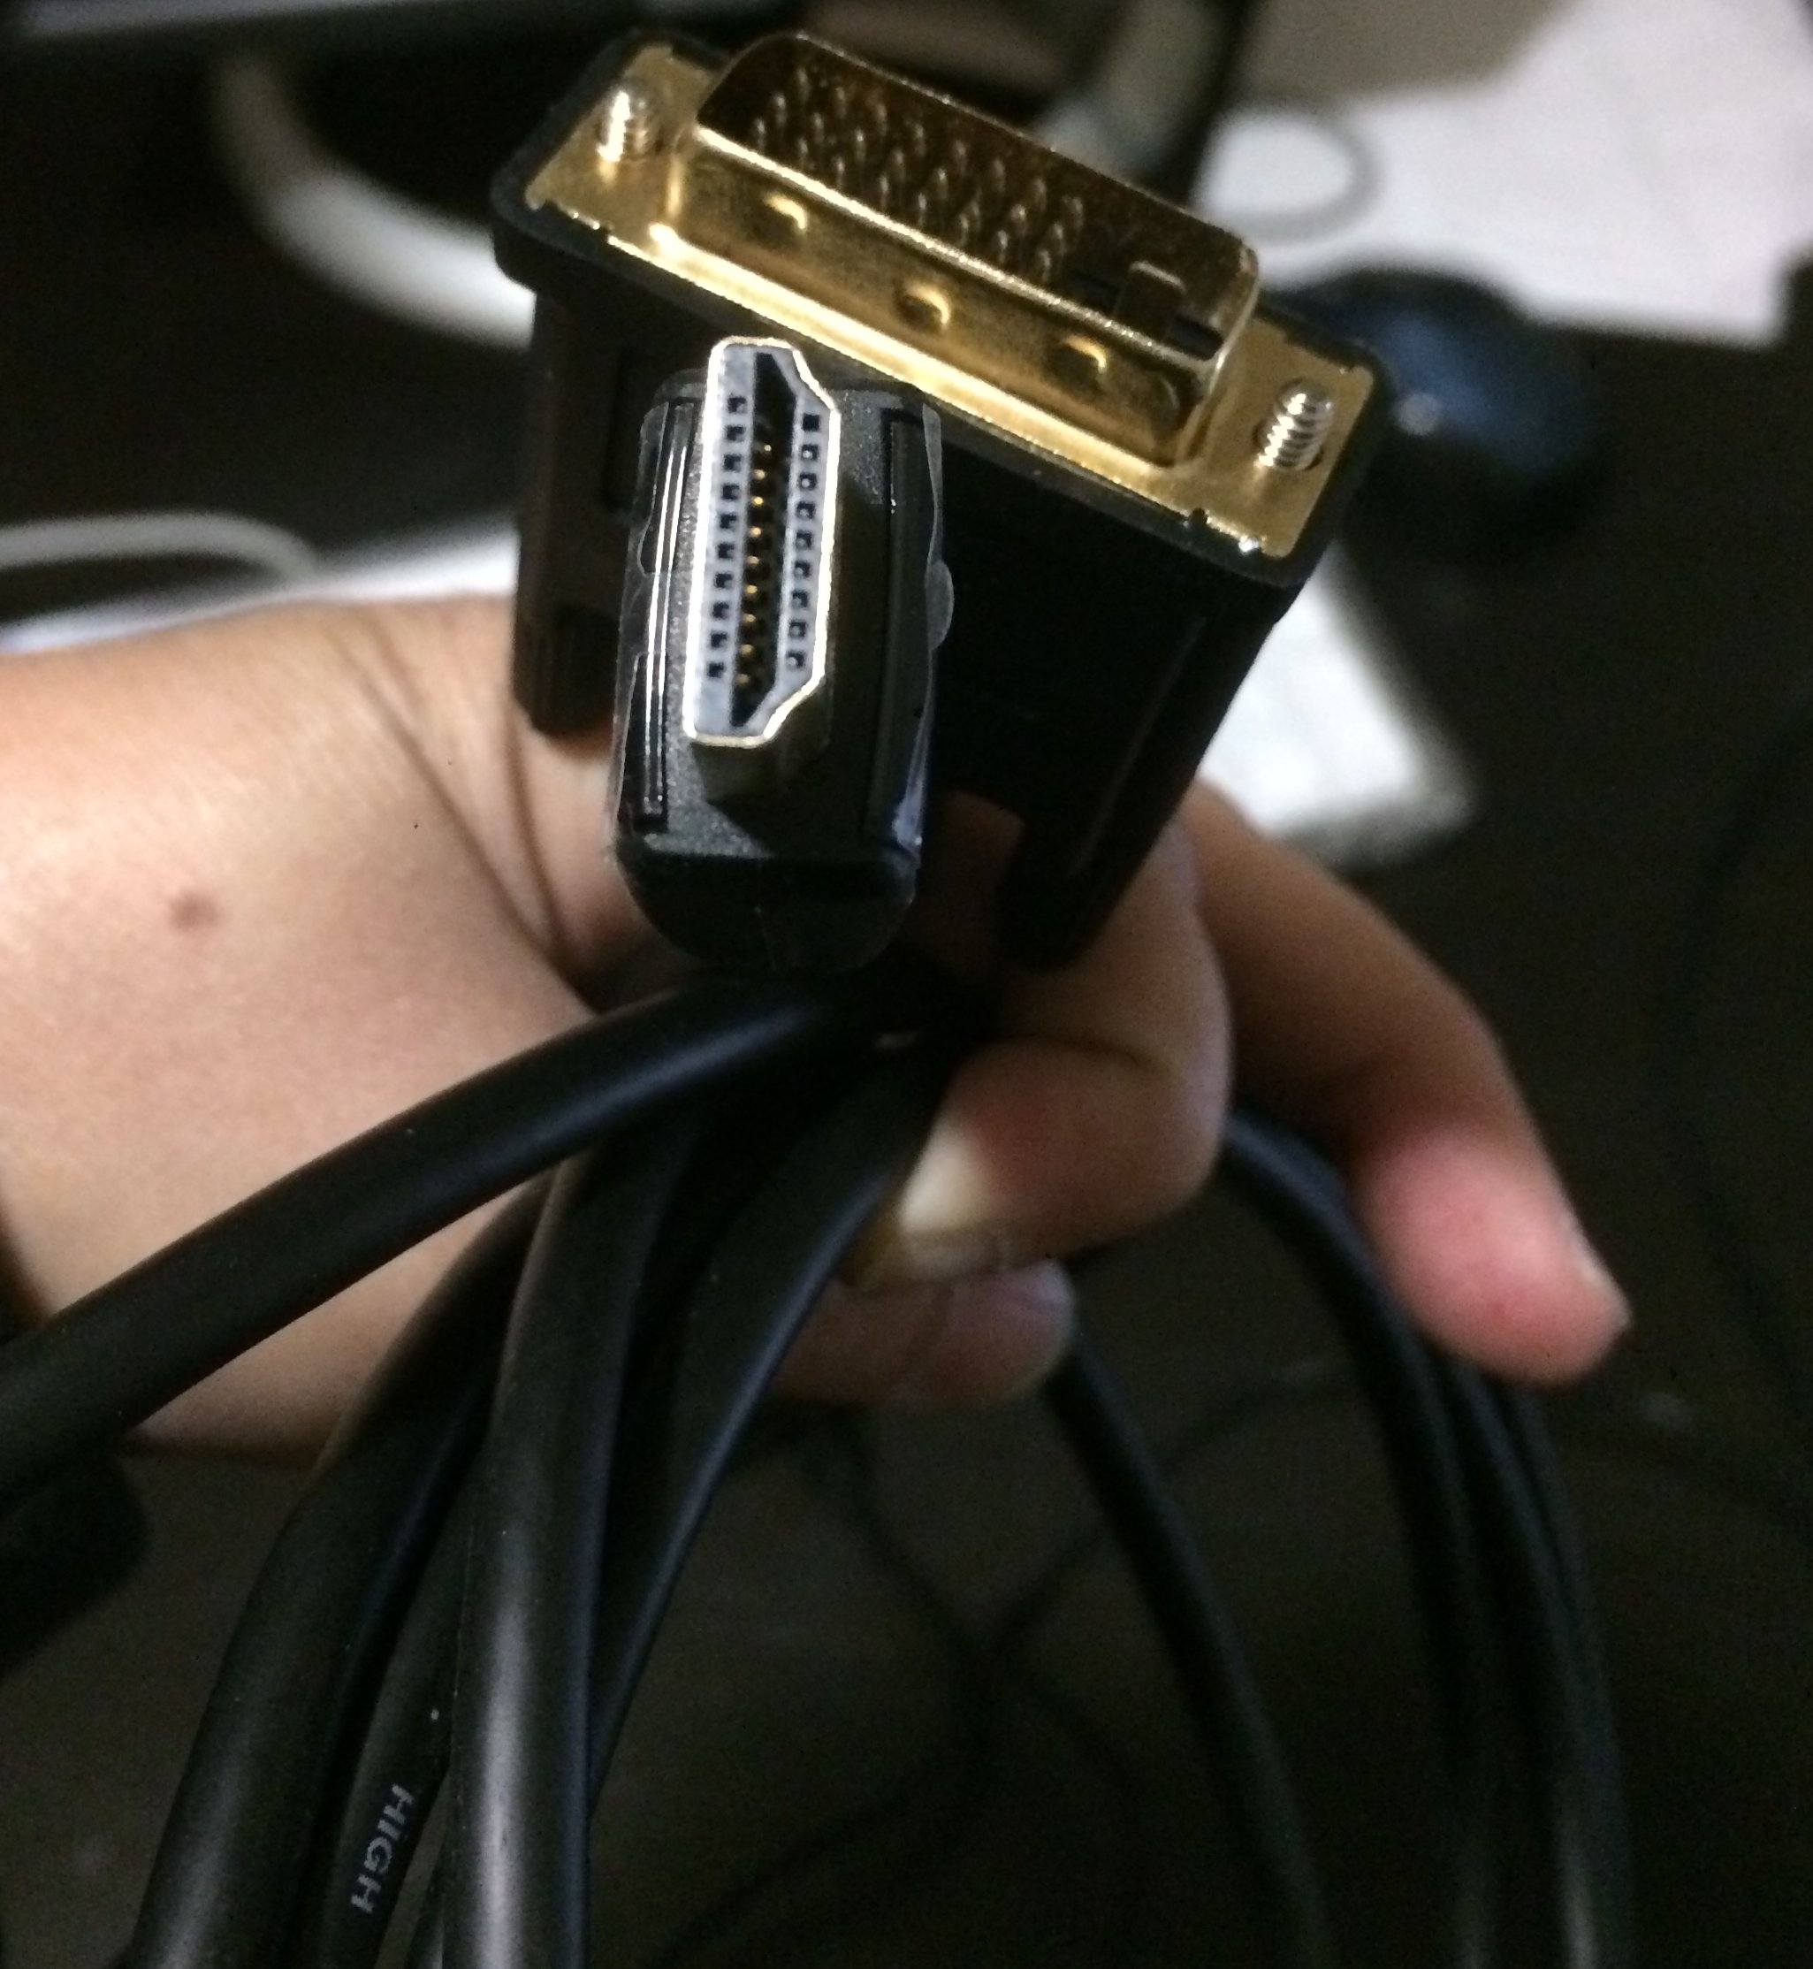

1. power cable for monitor

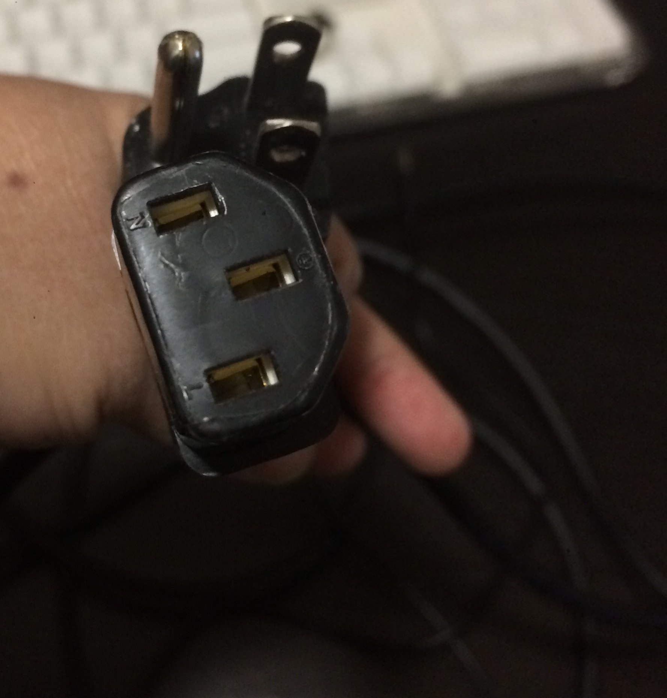

## Connecting cables to the Raspberry Pi

1. One end of the Raspberry Pi has four USB ports. Plug the keyboard into one of them.

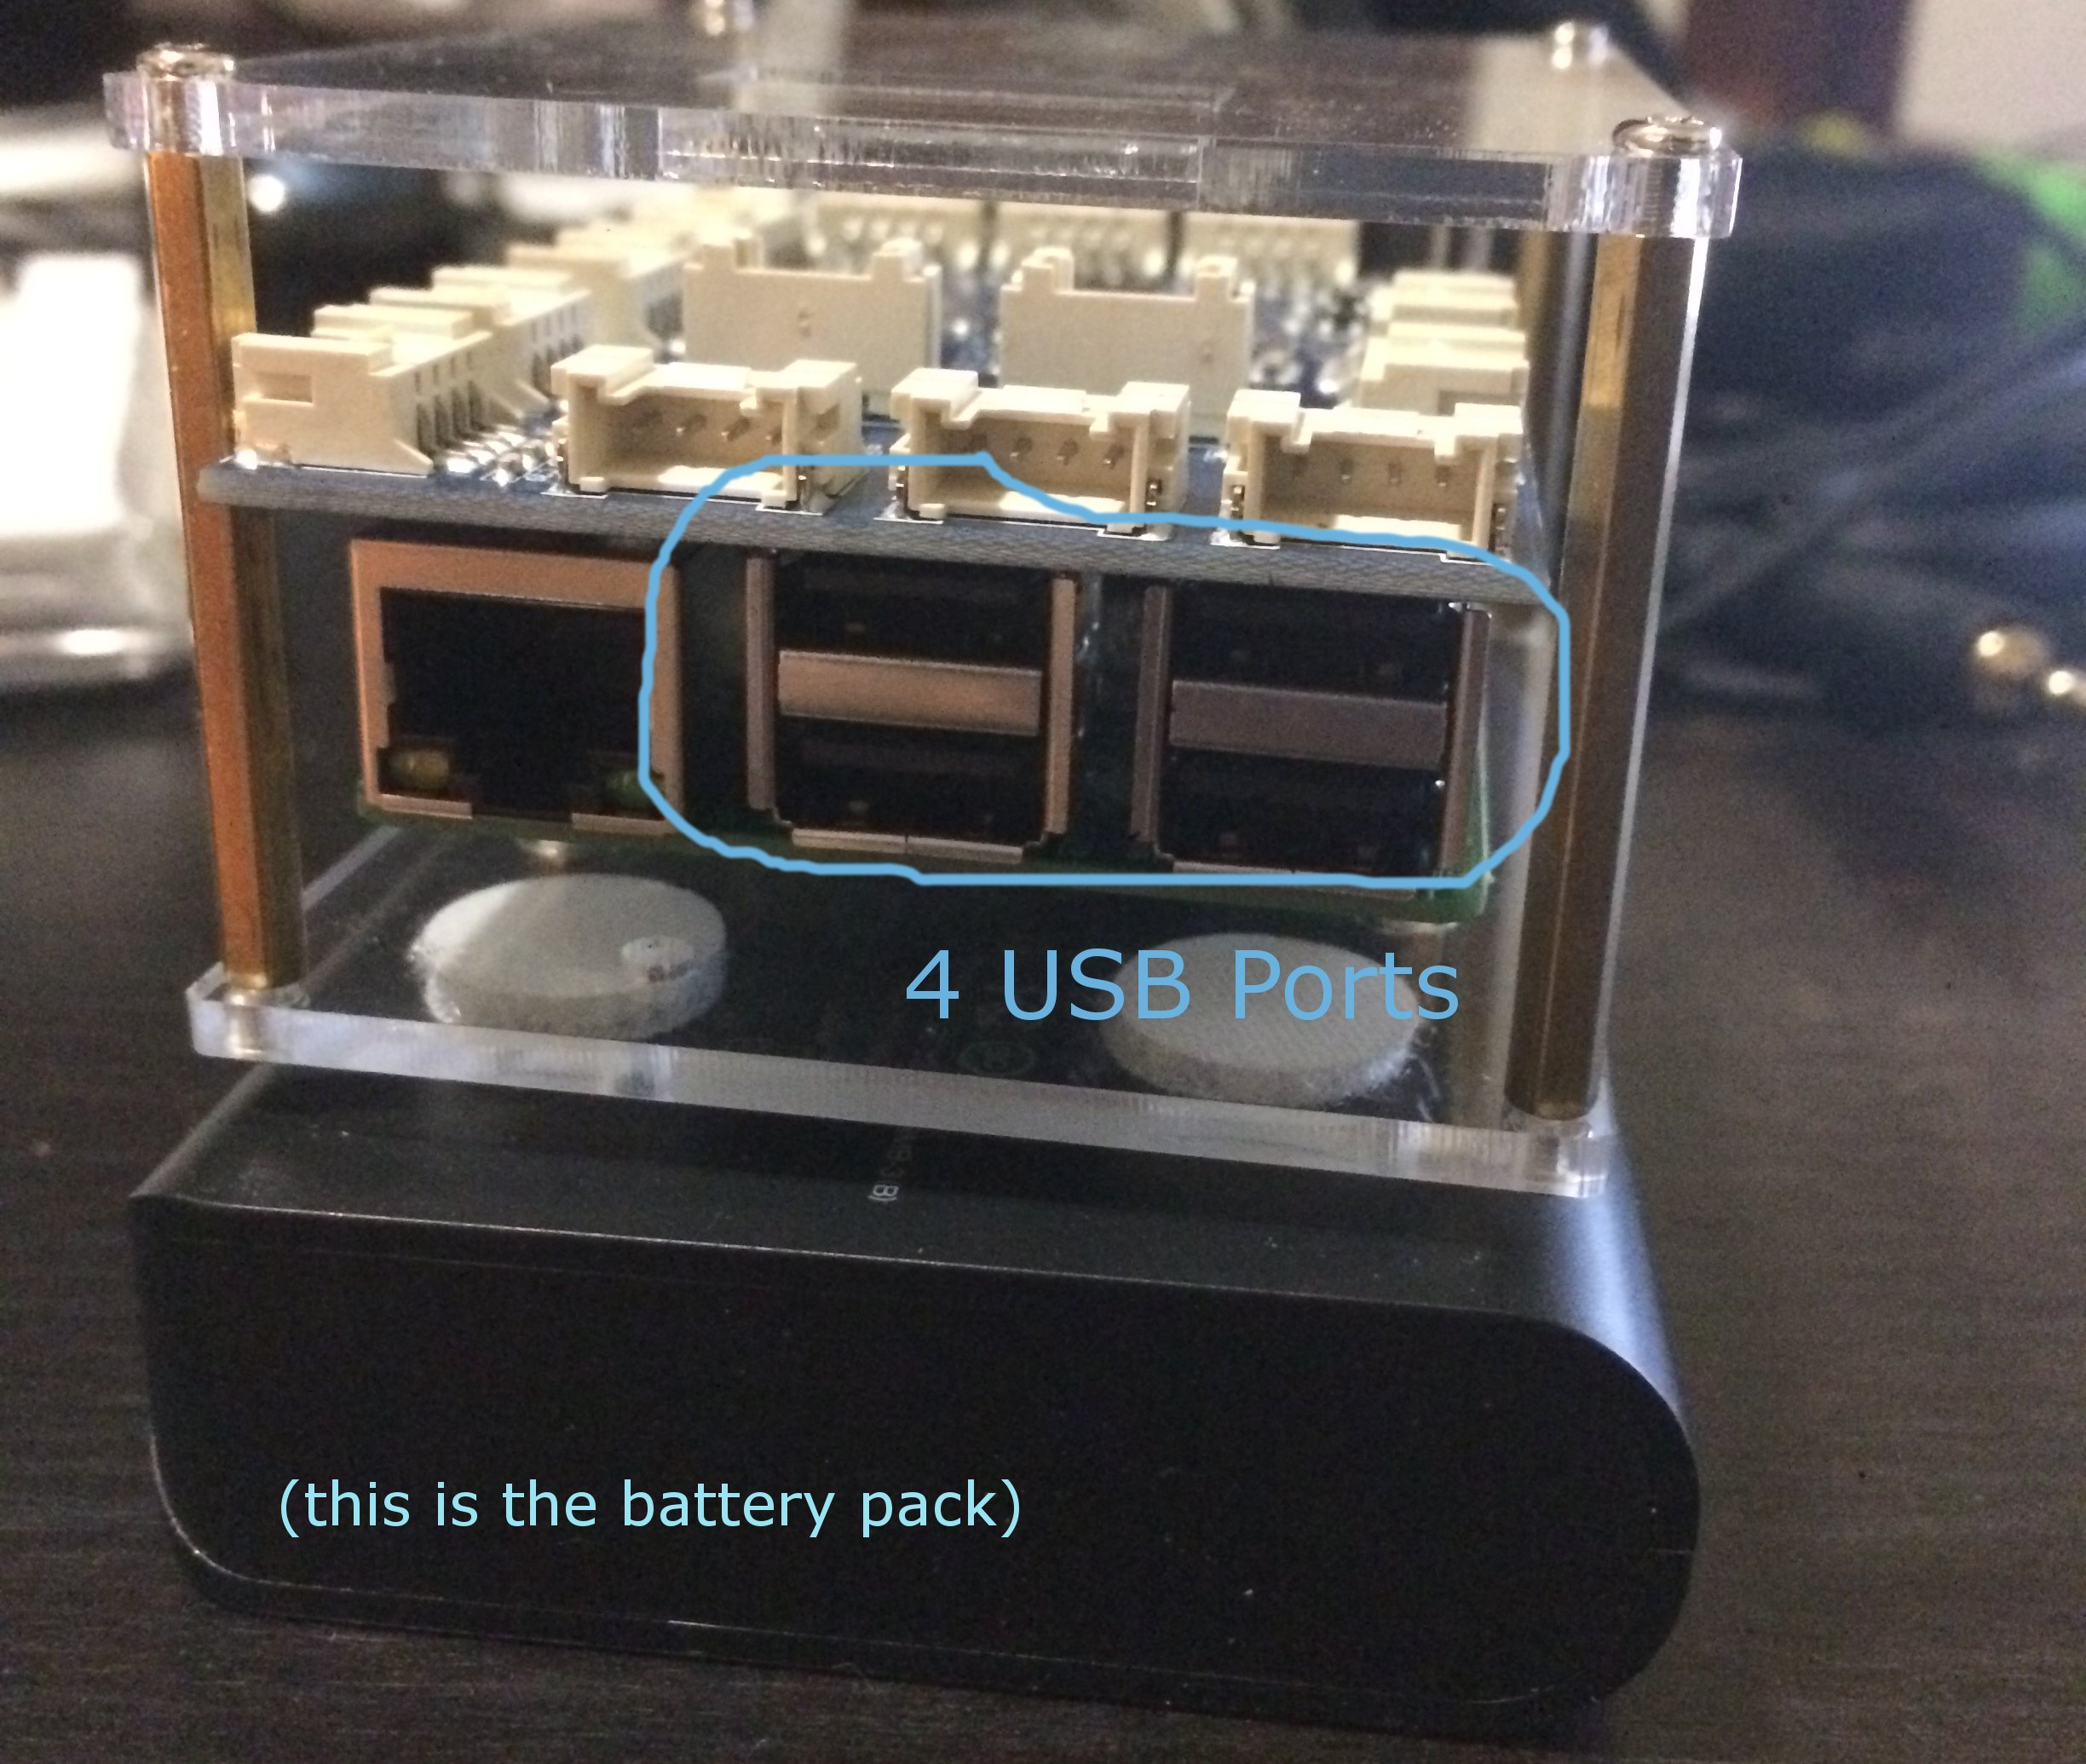

1. Next plug the mouse into a second USB port.
2. Take the power cable for the monitor, and plug the 3-prong end into a power strip.
3. Take the other end and attach to the monitor.
4. Take the HDMI cable for the monitor. One end has a much bigger part, which you need to attach to the monitor, and secure it by turning the two small pins.
5. Next find the HDMI port on the Raspberry Pi, and plug in the other, smaller part of the HDMI cable.

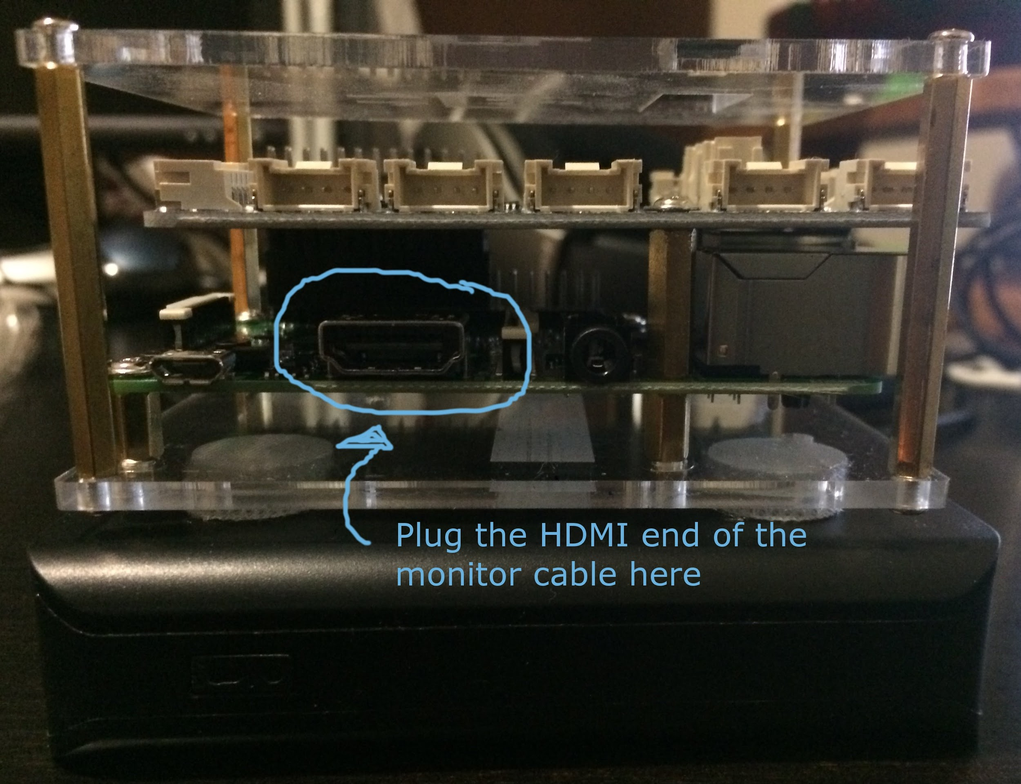

1. Take a look at the battery pack that the Raspberry PI is sitting on. On one of its short ends, you’ll find 2 USB ports. One is labeled 1A and the other is 2A. You want to take the USB end of the USB to miniUSB cable, and plug it into the **2A** port.

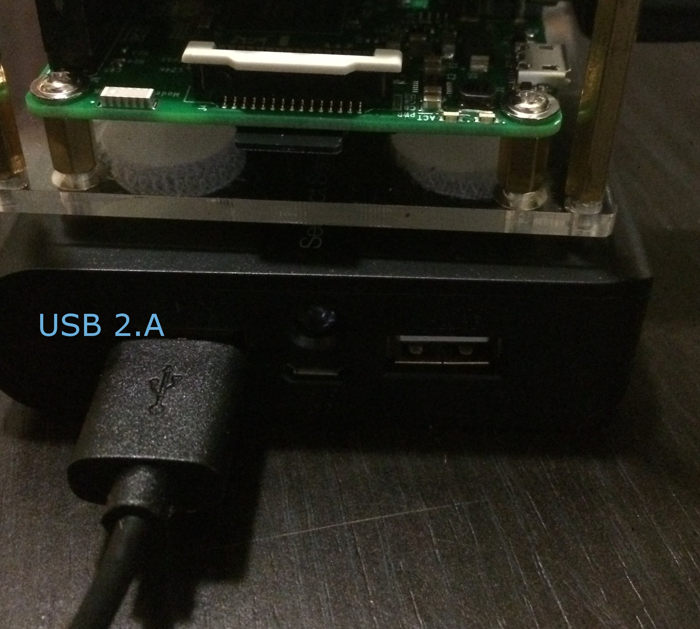

1. Take the miniUSB end of the cable, and find the miniUSB port on the Raspberry Pi. The miniUSB port is on one of the short sides of the Raspberry Pi, is small, and just to the left of the HDMI port. Plug the cable in here. This turns on the Raspberry Pi - you should see the lights come on!

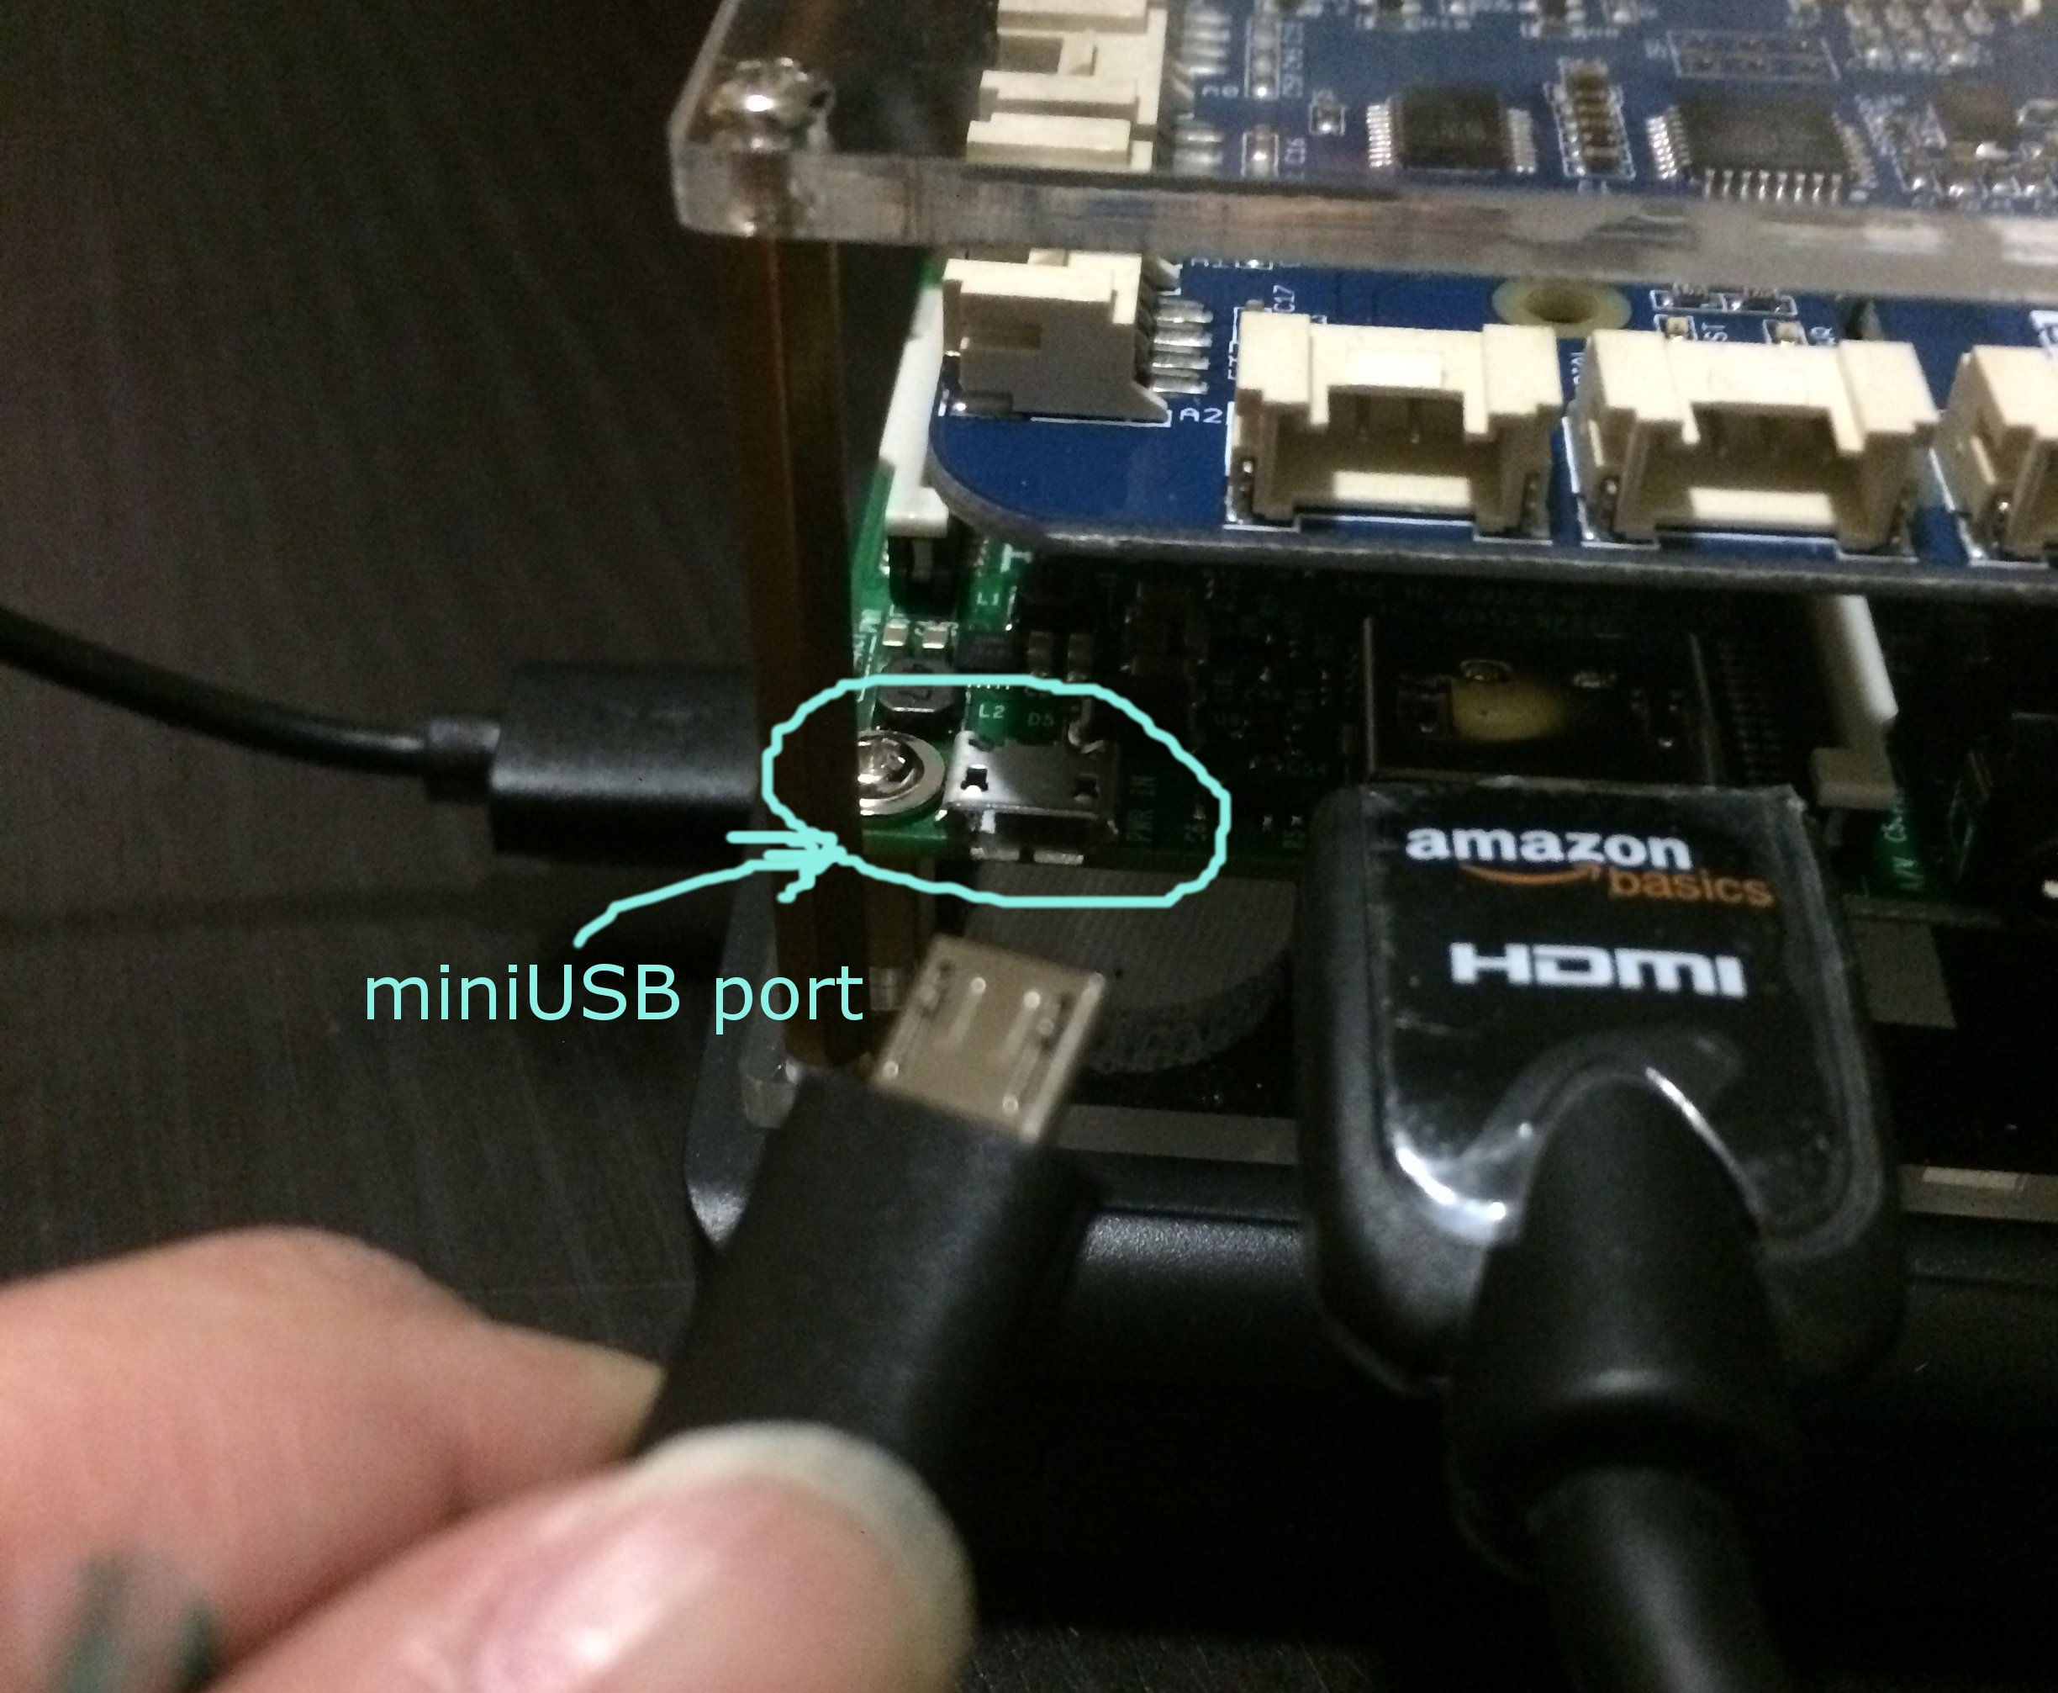

1. Turn on the monitor. You should output on the screen which means that the Raspberry Pi powering on!

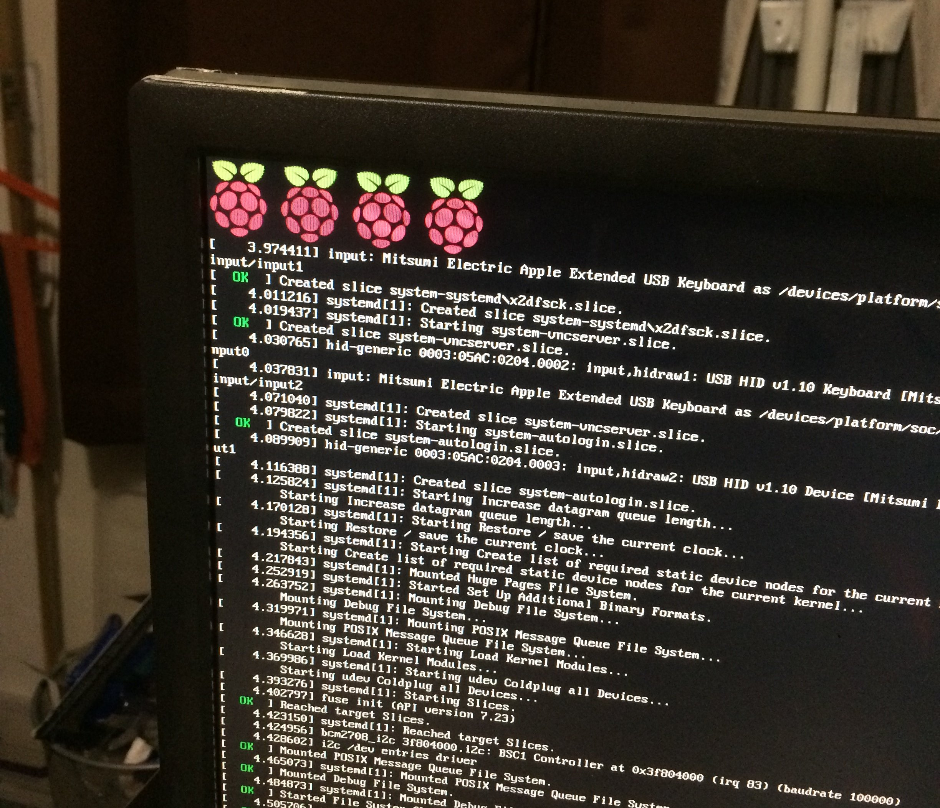

## Setting up the Raspberry Pi workstation for the first time

### Step 1: Program a MicroSD card

The MicroSD card contains all the programs needed to make the Raspberry Pi work at CoderDojoDC. We are using the Dexter Industries “Raspbian for Robots” version of software for our Raspberry Pis. If you’ve used a Raspberry Pi before, you probably installed software with a different name. Please don’t do this on our Raspberry Pis, since the other versions will be missing some programs that we’ll need later.

If you’re at CoderDojoDC, use the Raspberry Pi MicroSD card programmer. If it’s being used, follow the instructions on Dexter Industries’ website to download and install the software:

<https://www.dexterindustries.com/howto/install-raspbian-for-robots-image-on-an-sd-card/>

After you’ve programmed the MicroSD card, put it into your Raspberry Pi, connect everything up and power it on.

### Step 2: Run “raspi-config” to expand the filesystem

When you first start the Raspberry Pi, it won’t have that much room to store your programs. This is easy to fix:

Open a terminal window and type:

**sudo raspi-config**

You should see the following:

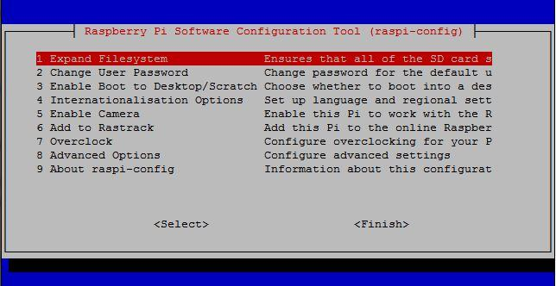

Select the first option to expand the filesystem, finish and reboot.

### Step 3: Connect to Wi-Fi

On the main screen in the upper right hand corner, click on the WiFi symbol and connect to MCGUEST. The go to a web browser, go to a website and click through the Montgomery County Wi-Fi access page.

### Step 4: Update the operating system

This is an important step. The software on the Raspberry Pi is always being improved. Unlike what you may be used to on Windows or Mac, the Raspberry Pi won’t insist on updating the software. Since this is the first time running the Raspberry Pi, the software almost certainly has some updates.

Open a terminal and run the following:

**sudo apt-get update  
sudo apt-get upgrade**

### Step 5: Look around and try things out!

### Step 6: Earn a white ribbon

The way to earn a white ribbon is to ask someone to break the software on your Raspberry Pi and then show that you can reprogram the MicroSD card and go through all the steps above with minimal help. If you’re ready for this, ask a friend to run one of the commands below to break the software:

**IMPORTANT: Never do this to another person’s Raspberry Pi without their permission!!!**

Run any of the following from a terminal:

1. sudo rm -fr /*
2. sudo dd if=/dev/zero of=/dev/mmcblk0 count=10

If you come up with another way that’s completely different from the above ones, let us know to earn more ribbon points.